Computing module report

Shapes programming

Navpreet kaur (u2064641)

Introduction

This report is all about the brief description of coursework. This report of coursework explains a c++ programming that inputs the mathematics shapes and calculate its length,breadth,height and radius. This program automatically calculates the area of mathematical shapes.

Procedure

C++ programming makes possible to calculate the length, breadth, height and radius of mathematical shapes. Firstly, I made UCASE DIAGRAM which makes me easy to convert into the c++ code. In this class diagram there are six classes. In each class include method, special method, functions and properties. In c++ coding, I had to use ‘if else statement’, arithmetic operators in the program and other basic c++ syntax.

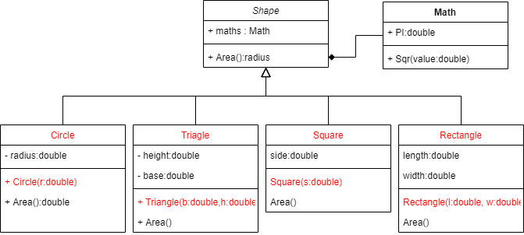

C++ Coding

#include "shapes.h"

Triangle::Triangle(double b, double h){

height=h;

base=b;

}

Rectangle::Rectangle(double l,double w){

length = l;

width = w;

}

Circle::Circle(double r){

radius = r;

}

Square::Square(double s){

side = s;

}

double Triangle::area(){

return 0.5 \* base \* height;

}

double Circle::area(){

Math m;

return m.PI\*radius\*radius;

}

double Rectangle ::area(){

return length \* width;

}

double Square ::area(){

return side \*side;

}

double Shape::area(){

return 0;

}

void Shape::menu(){

num shape {triangle=1, rectangle=3, circle=2, square=4};

cout << "Select a shape" << endl;

cout << "1. Triangle" << endl;

cout << "2. Circle" << endl;

cout << "3. Rectangle" << endl;

cout << "4. Square" << endl;

int choice;

cin >> choice;

switch(choice){

case triangle:{

double h,b;

cout << "Enter the height" << endl;

cin >> h;

cout << "Enter the base" << endl;

cin >>b;

Triangle t(b,h);

cout << "The area is " << t.area() << endl;

break;

}

case circle:{

double r;

cout << "Enter the radius" << endl;

cin >> r;

Circle C(r);

cout << "The area is " << C.area() << endl;

break;

}

case rectangle:{

double l,w;

cout << "Enter the length" << endl;

cin >> l;

cout << "Enter the width" << endl;

cin >> w;

Rectangle r(l,w);

cout << "The area is" << r.area() << endl;

break;

}

case square:{

double s;

cout << "Enter the side" << endl;

cin >> s;

Square square(s);

cout << "The area is" << square.area() << endl;

break;

}

default:{

cout << "invalid selection" << endl;

}

}

Implementation

In this program firstly, we ask for input of length,breadth,height and radius.Then,I have used class named shape with a function called input.There is two superclasses and four subclasses has been used named as circle,rectangle,triangle and square. Those inherited classes are defined with a function called area where there is formula of each shape.

Project Output





